# CS2102 Project Report

## Found Together

|  |  |
| --- | --- |
| **Duan Yanjuan** | **A0133887R** |
| **Li Zan** | **A0133894W** |
| **Xiao Yuxin** | **A0131334W** |
| **Liang Yuan** | **A0133975W** |
| **He Buwei** | **A0119434H** |

### Introduction

The popularization of Internet and the ubiquitous mediascape we inhabit today provide a new approach, online platform, for crowdfunding activities. Crowdfunding websites had raised US$89 million worldwide for individuals and companies in 2010, US$1.47 billion in 2011 and US$2.66 billion in 2012 (MacLellan, 2013). Our project **Found Together**, a web appilication, provides an online platform for entrepreneurs to advertise their projects and raise money from individuals. Entrepreneurs register first and then post their projects with specific information, including title, description, start date, end date, category, status and target amount, to **Found Together**. Entrepreneurs can view, edit, close/open their own projects. Individuals (guests) can browse or search for projects, but they need to register as a valid user first in order to donate money to their desired project. Valid users can view their personal records of previous funding history and edit, view their personal profile. Administrators of the application have the accessibility to create, modify, and delete entrepreneurs, projects or users, in order to ensure the application is protected, up-to-date, persistent, informative and understandable.

Our web application is established on **Apache,** which is a Web server that allows developers to build and run their Web applications**.** In order to store and retrieve data**,** it interacts with the database management system, which is **ProstgreSQL** in our choice.

As for programming language, we use **HTML**, **PHP** and **SQL** to implement our application. HTML and SQL are respectively used to build the front-end user Interface and back-end database frame. The PHP is used to build the logic between the front end and back end. We will introduce the detailed application in the following parts.

### ER Diagram

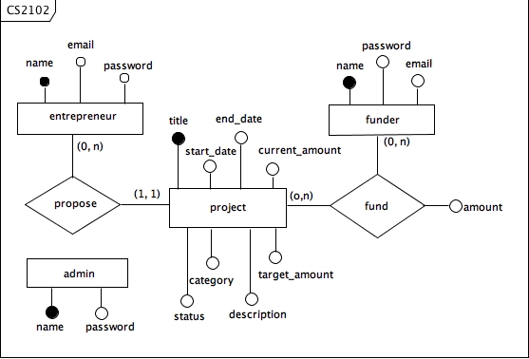

### Relational Scheme

DROP TABLE IF EXISTS funder;

DROP TABLE IF EXISTS entrepreneur;

DROP TABLE IF EXISTS admin;

DROP TABLE IF EXISTS fund;

DROP TABLE IF EXISTS project;

CREATE TABLE funder(

name VARCHAR(255) PRIMARY KEY,

password VARCHAR(255) NOT NULL,

email VARCHAR(255) NOT NULL UNIQUE

);

CREATE TABLE entrepreneur (

name VARCHAR(255) PRIMARY KEY,

password VARCHAR(255) NOT NULL,

email VARCHAR(255) NOT NULL UNIQUE

);

CREATE TABLE admin (

name VARCHAR(255) PRIMARY KEY,

password VARCHAR(255) NOT NULL

);

CREATE TABLE project (

title VARCHAR(255) PRIMARY KEY,

description TEXT,

owner VARCHAR(255) NOT NULL,

start_date DATE NOT NULL,

end_date DATE NOT NULL,

category VARCHAR(255) NOT NULL,

target_amount INT NOT NULL,

current_amount INT DEFULT 0,

status BOOLEAN DEFAULT TRUE,

FOREIGN KEY (owner) REFERENCES entrepreneur(name) ON UPDATE CASCADE ON DELETE CASCADE,

CHECK (target_amount > 0),

CHECK (end_date > start_date)

);

CREATE TABLE fund (

funder_name VARCHAR(255) REFERENCES funder(name) ON UPDATE CASCADE,

project_title VARCHAR(255) REFERENCES project(title) ON UPDATE CASCADE,

amount FLOAT,

CHECK (amount > 0)

);

### Representative Queries

1. List out all the valid funders

SELECT f.name, f.email FROM funder f;

2. List out all the projects currently looing for crodfunding

SELECT p.title, p.description, p.start_date, p.end_date, p.category, p.target_amount, p.current_amount

FROM project p WHERE p.status = true;

3. List out all the projects in the education category

SELECT p.title, p.description, p.start_date, p.end_date, p.category, p.target_amount, p.current_amount,

CASE WHEN p.status <> true THEN 'closed' ELSE 'open' END

AS education

FROM project p WHERE p.category = 'education';

4. List out all the projects funder buwei has donated money to

SELECT p.title, p.description, p.owner, p.start_date, p.end_date, p.category, f.amount,

CASE WHEN p.status <> true THEN 'closed' ELSE 'open' END

FROM project p, fund f

WHERE f.project_title = p.title AND f.funder_name = 'buwei';

5. List out all the funders who have donated money to project computers

SELECT u.name, f.amount

FROM funder u, fund f, project p

WHERE f.funder_name = u.name AND f.project_title = p.title AND p.title = 'computers';

6. List out all the projects related to entrepreneur growup

SELECT p.title, p.description, p.owner, p.start_date, p.end_date, p.category, p.target_amount, p.current_amount,

CASE WHEN p.status <> true THEN 'closed' ELSE 'open' END

FROM project p WHERE p.owner = 'growup';

7. List out all the projects funder yuxin has donated according to increasing order of donating amount

SELECT p.title, p.description, p.owner, p.start_date, p.end_date, p.category, p.target_amount, p.current_amount,

CASE WHEN p.status <> true THEN 'closed' ELSE 'open' END

FROM project p, fund f

WHERE f.funder_name = 'yuxin' AND f.project_title = p.title

ORDER BY f.amount ASC;

### User Interface

1. Home page
2. Log in page
3. Some other pages....

### References:

1. MacLellan, Kylie (August 04, 2013 )Global Crowdfunding Volumes Rise 81% In 2012. Retrieved from: http://www.huffingtonpost.com/2013/04/08/global-crowdfunding-rises-81-percent_n_3036368.html